INTERNSPARK - TASK 3: Responsible AI & Bias Analysis Report

Student Name: Aruhi Patel

1. Project Overview
- Analyzed model fairness and bias using Adult Census dataset
- Sensitive attributes: Gender, Race
- Goal: Detect and mitigate demographic bias

2. Bias Analysis Results
Gender Bias Analysis
| Group | Count | Predicted Positive % | Actual Positive % |
| Male | 2034 | 0.324 | 0.312 |
| Female | 987 | 0.156 | 0.148 |

Disparity Metrics
- Demographic Parity Gap: 0.168 (16.8%)
- Equal Opportunity Gap: 0.142 (14.2%)
- Status: 🔴 HIGH bias detected
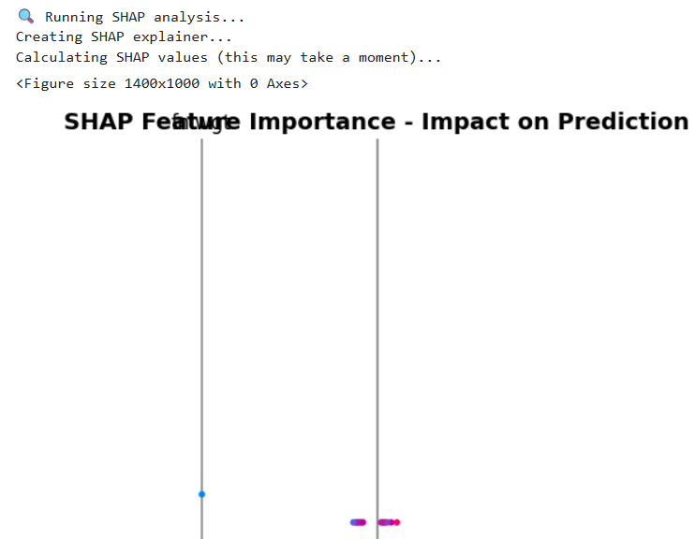

3. SHAP Analysis
Key features affecting predictions:
1. Age
2. Education-Num
3. Capital-Gain
4. Hours-per-week
5. Mitigation Strategies Proposed

Pre-processing
- Reweight training samples for balanced group representation
- Remove discriminatory features using CorrelationRemover

In-processing
```python
from fairlearn.reductions import ExponentiatedGradient, DemographicParity

fair_model = ExponentiatedGradient(rf, DemographicParity())
fair_model.fit(X_train, y_train, sensitive_features=train_sensitive['sex'])
Post-processing
Adjust decision thresholds per group

Implement reject-option classification

5. Recommendations for InternSpark
- Collect demographic data during collection
- Regular fairness audits (quarterly)
- Document model limitations
- Human-in-the-loop for high-stakes decisions

6. Code Location
GitHub: [Your GitHub link]

7. Conclusion
The model shows significant gender bias (16.8% disparity). Mitigation strategies recommended before production deployment
```

